|  |  |
| --- | --- |
| **CHED IAS Endorsement Checklist**  **Foreign Travel** | |
|  | 1. Letter Request to Travel Abroad |
|  | 1. Dully Filled-out CHED IAS Form 15 |
|  | 1. Formal Invitation/ Letter of Acceptance |
|  | 1. Profile of the Organizer |
|  | 1. Background Information of the Conference/ Workshop/ Meeting |
|  | 1. Programme of the Event |
|  | 1. Narrative Report (to be submitted w/in   5-days after the trip) |

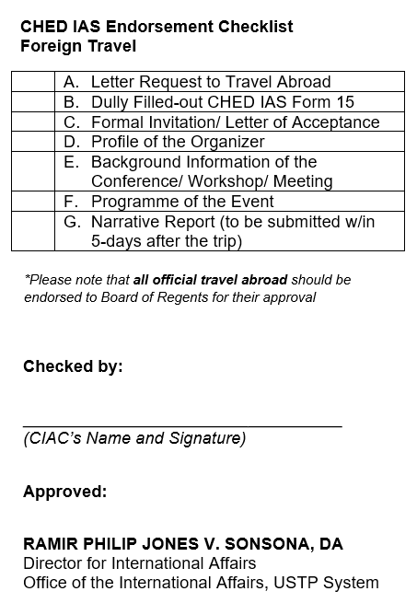

*\*Please note that* ***all official travel abroad*** *should be endorsed to Board of Regents for their approval*



**Checked by:**

__________________________________

*(CIAC’s Name and Signature)*

**Approved:**

**RAMIR PHILIP JONES V. SONSONA, DA**

Director for International Affairs

Office of the International Affairs, USTP System